Assignment Day 8 | 9th December 2020

**Name: Pratik Mahakalkar**

# For any doubts regarding the assignment, ask questions in the L

[**Administration 101 B1**](https://community.letsupgrade.in/group/linux-administration-101-b1) **Group in the Community. Submit Assignments by 12th December 2020 11:59 PM.**

[**inux**](https://community.letsupgrade.in/group/linux-administration-101-b1)



**Assignment Submit Form :**[**https://forms.gle/9MNzWbdDXhhdstWEA**](https://forms.gle/9MNzWbdDXhhdstWEA)

**Submit assignments in Appropriate Dropdowns.**

**Assignment 0**

1. Create a simple shell script to tell the user about their session – they need to know:
   * What their username is
   * What the current date is
   * What the time is
   * What their current working directory is
   * How many files they have in that directory
   * What is the biggest file in their current directory

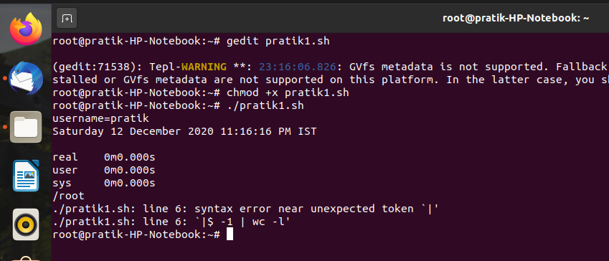

# Assignment 1

Create a directory with a few test files in it (the files can be empty). Now write a script that for every file in that directory you rename it to have an extension of today's date in YYYYMMDD format.\

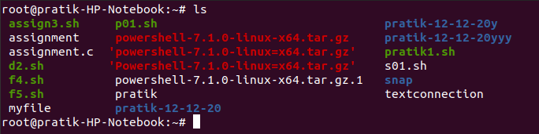

# Assignment 2

Write a script that takes a number as an input and reverses it out to the user. For example, if the original number is 74985, the output should be 58947.

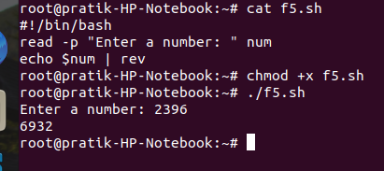

# Assignment 3

Write a script to validate how secure someone's password is. Things you would care about:

* + Length should be 8 or more characters
  + The password should contain numbers and letters
  + There should be both uppercase and lowercase letters

